CMC 043-23 ATTENTION ALL RUNNING TRADES - CANADA
---------------------------------------------------------------------------------------------------------------------
SUBJECT: 2024 GENERAL HOLIDAY SCHEDULE - ALL REGIONS

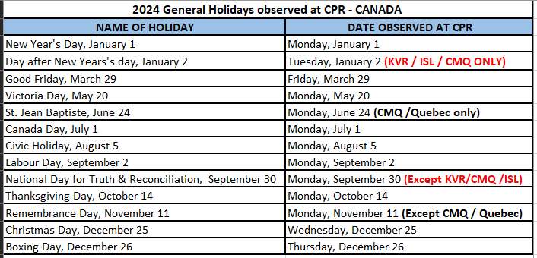
CORRECTOR #1

General Holiday payment entitlement is based on the eligibility criteria specified in the TCRC Consolidated Collective Agreement. In order to qualify for a General Holiday payment you must meet the requirements set out in the collective agreement.

You are reminded that CMA automatically generates some General Holiday payments. However, should your claim not auto generate five (5) calendar days after the date the General Holiday is observed and you meet the specified criteria outlined in the collective agreement, you are required to enter your own “SH” claim into CMA. The “SH” claim code is a dollar based claim code (refer to CMA MAC4 Screen 12 PF10 for a list of claim codes). Please do not submit an “SH” claim prior to five (5) calendar days after the General holiday observation date, as doing so may result in duplicate payment and delay to the processing of your General Holiday payment.

Employees submitting an “SH” claim are responsible to review their timeslips and deposit notification for any possible overpayments and/or underpayments and report them before the next pay period cut off (via IP Claim in CMA, phone (VRU) or e-mail).

Employees who are cancelled on their respective yards or assignments on a day(s) other than the general holiday but because of the general holiday and are entitled to a cancellation payment may submit a “CJ” claim for that (those) day(s). Overtime paid will only be applicable on the observation date(s) for the General Holiday.

